Unearthing the Environmental Impact of Human Activity:

A Global CO2 Emission Analysis

**INTRODUCTION:**

OVERVIEW:

Carbon dioxide emissions or CO2 emissions are emissions stemming from the burning of fossil fuels and the manufacture of cement; they include carbon dioxide produced during consumption of solid, liquid, and gas fuels as well as gas flaring.

PURPOSE:

The carbon in CO2 can be used to produce fuels that are in use today, including methane, methanol, gasoline and aviation fuels.

**PROBLEM DEFINITION AND DESIGN THINKING:**

EMPATHY MAP:

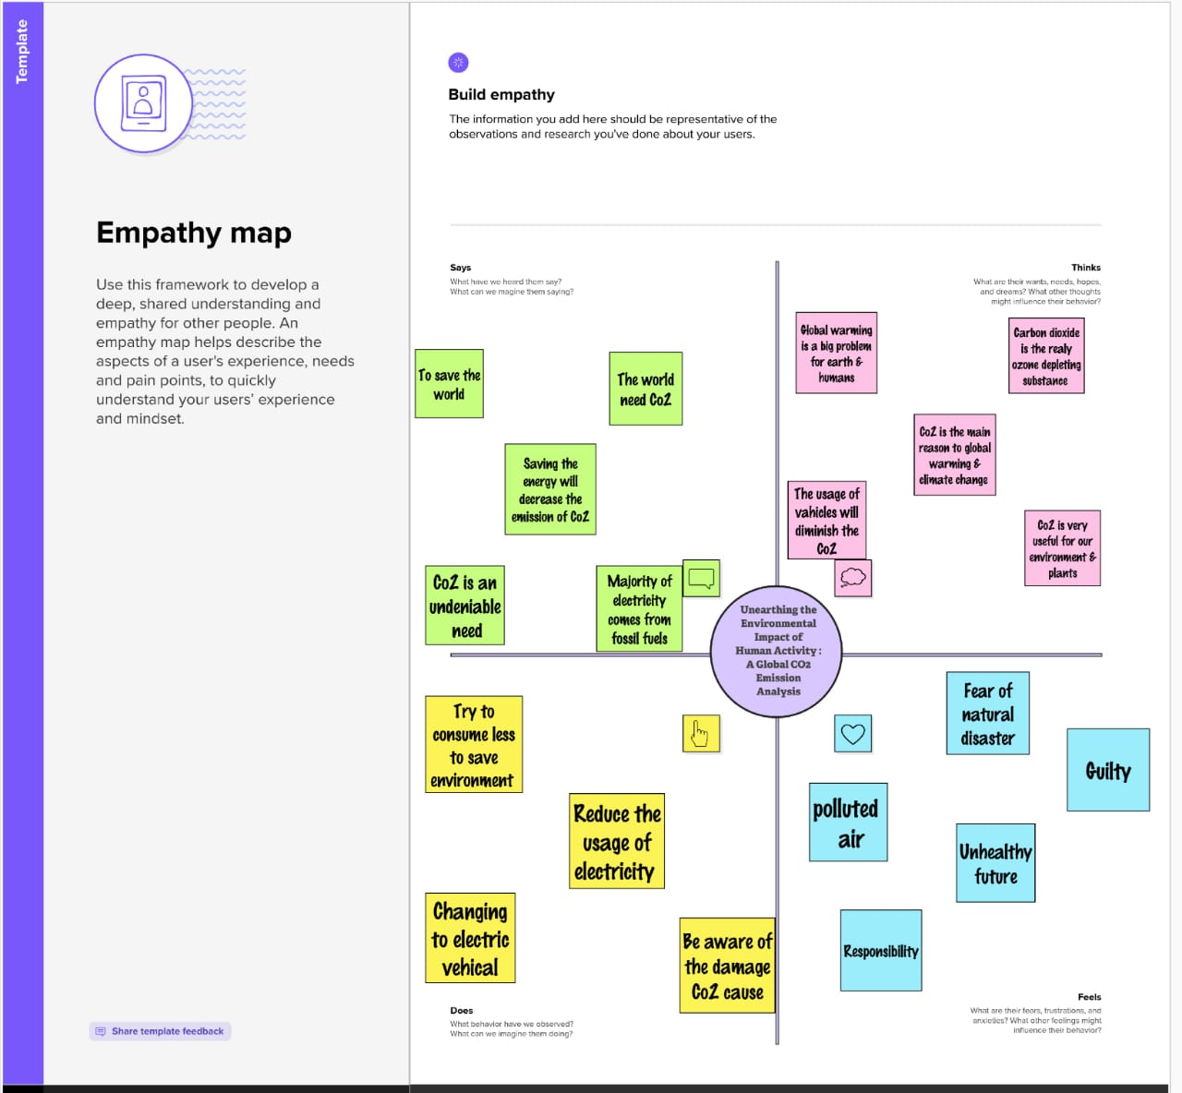

IDEATION AND BRAINSTORMING MAP:

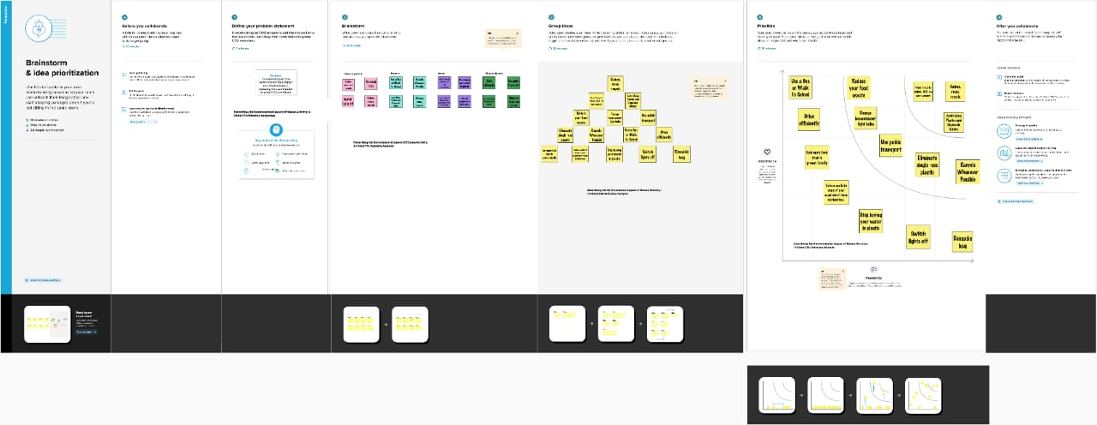

**RESULT :**

Data sets are collected from the Kaggle and stored in MYSQL and merged with the tableau software.

Typically, the findings of Co2 Emission analysis are published in a Tableau public that may include recommendations that the relevant authorities or industry organizations may implement.

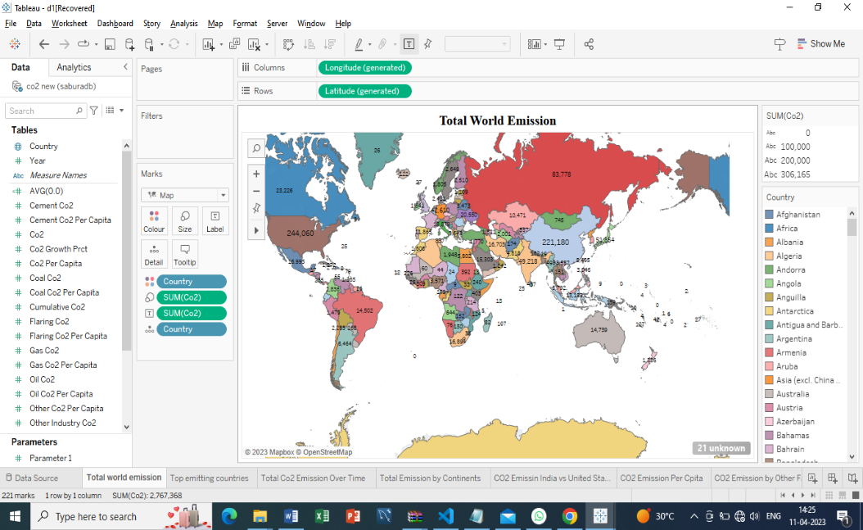 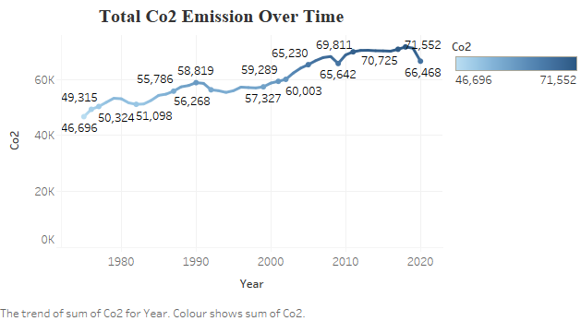

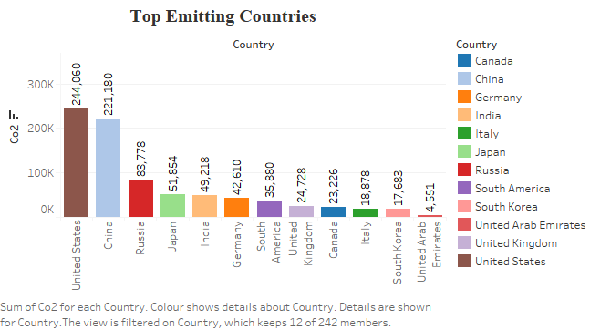 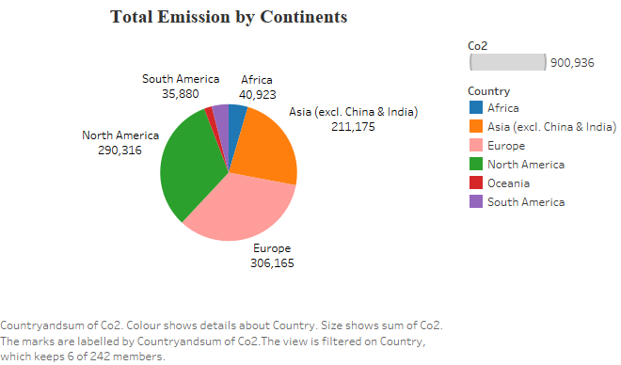

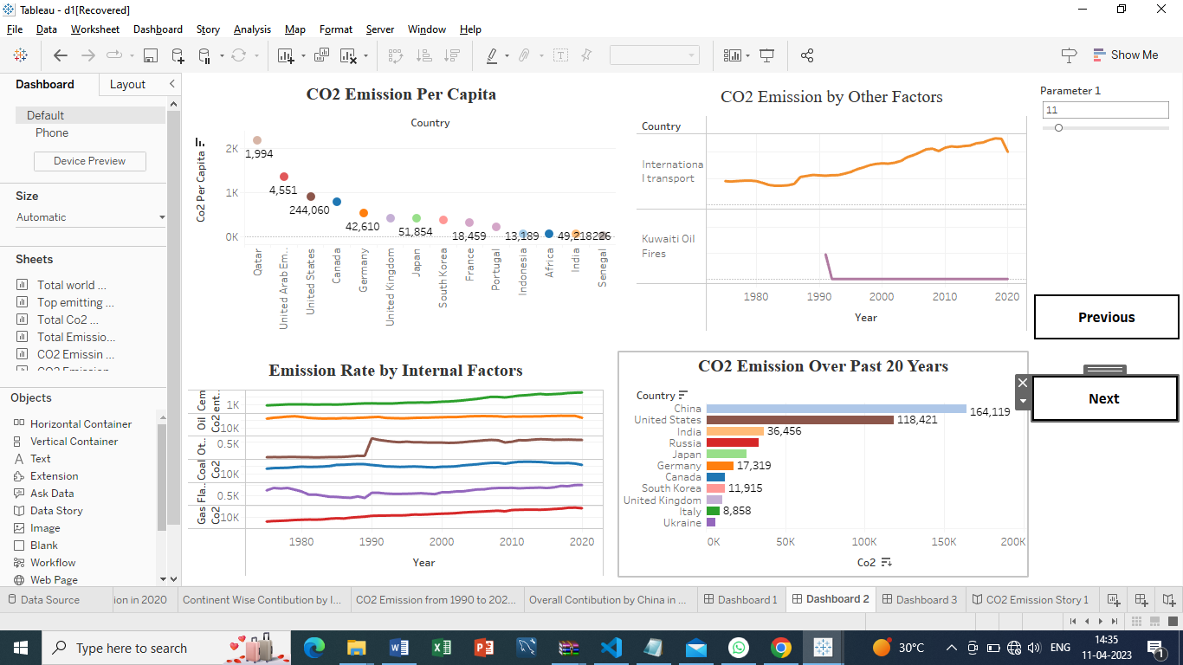

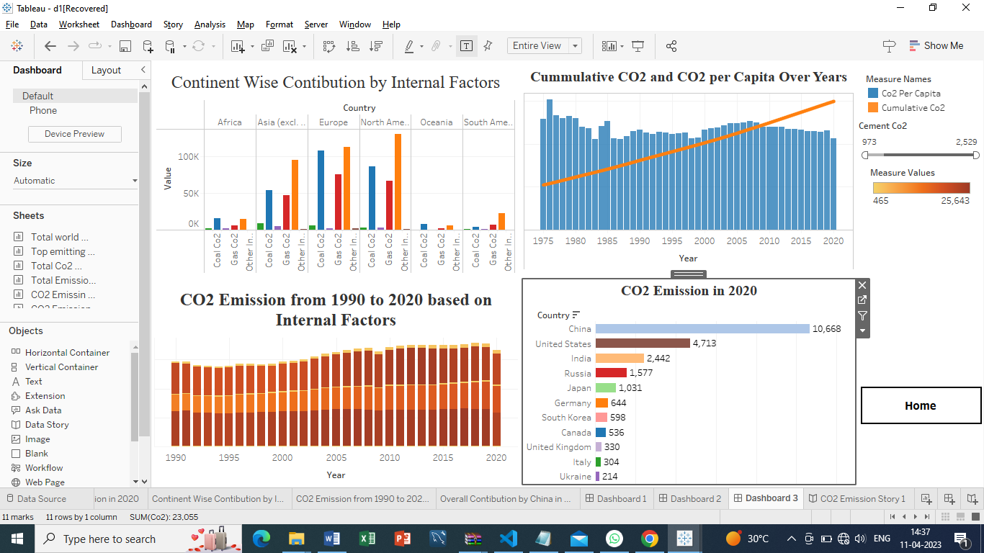

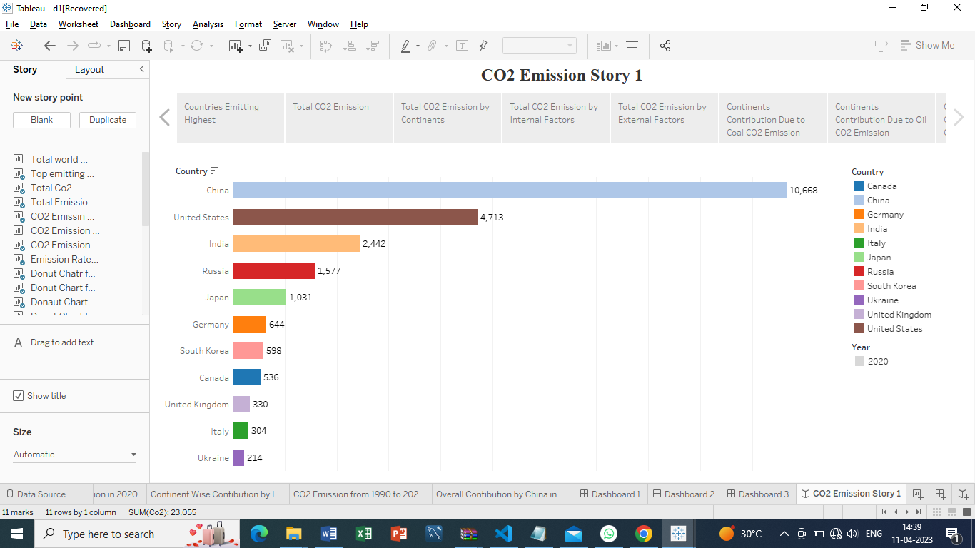

|  |  |
| --- | --- |
| ADVANTAGES | DISADVANTAGES |
| Green plants grow faster with more CO2. Many also become more drought- resistant because higher CO2 levels allow plants to use water more efficiently. | CO2 emissions act like a blanket in the air, trapping heat in the atmosphere, and warming up the Earth. |
| More abundant vegetation  from increased CO2 is already apparent | This layer prevents the Earth from cooling, and thus raises global temperatures. |
| CO2 plays various roles in the human body including regulation of blood pH, respiratory drive, and affinity of haemoglobin for oxygen (O2). | Global warming would affect environmental conditions, food and water supplies, weather pattern, and sea levels. |

**APPLICATIONS:**

* Detail analysis about co2 emission.
* Control the factors.
* Future predication about co2
* Online data analysis

**CONCLUSION:**

This webpage help to know about the emission of CO2 gases all over the world .This story and dashboard are the analysis of Co2 emission and helps to find the factors and control the factors.

**FUTURE SCOPE:**

* The scope of CO2 emissions in this report includes emissions from all uses of fossil fuels for energy purposes, including the combustion of non-renewable waste, as well as emissions from industrial processes such as cement, iron and steel, and chemicals production.
* Emissions are direct emissions from owned or controlled sources. Emissions are indirect emissions from the generation of purchased energy.
* Emissions are released into the atmosphere as a direct result of a set of activities, at a firm level.
* Avoided emissions, also referred to as emissions, can be defined as reductions that occur outside of a product's life cycle or value chain, but as a result of the use of that product.

**APPENDIX:**

